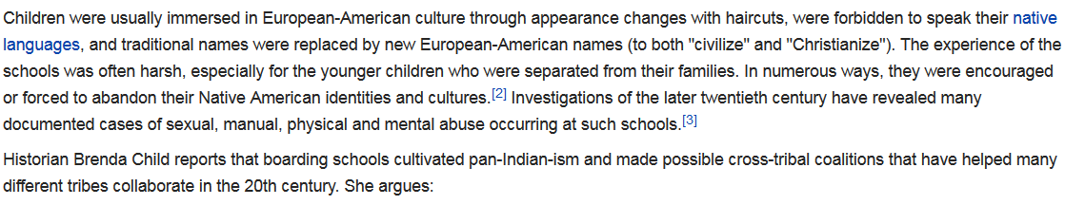The Carlisle Indian Industrial School, founded by the US Army officer [Richard Henry Pratt](https://en.wikipedia.org/wiki/Richard_Henry_Pratt) in 1879 at a former military installation

great general has said that the only good Indian is a dead one.

He cut their long hair, put them in uniforms, forced them to learn English, and subjected them to strict military protocols